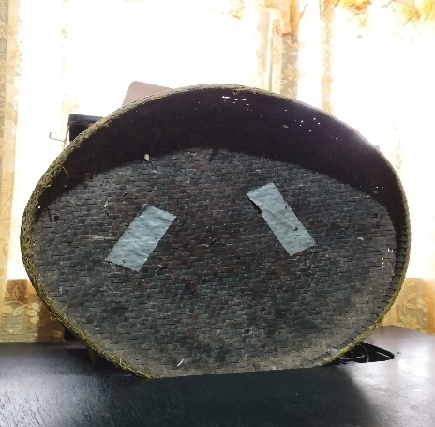
Art Appreciation
Activity 1
Date: February 7, 2023
Name: John Jenoel G. Quimora
Course: BSIS 1B

- DESCRIPTION OF THE ARTWORK, PRODUCT OF ARTIFACT:
Name: Bilao
Color: Brown
Composition: It is made from bamboo.
Other information: It is woven fan shaped basket used for drying grains of rice and shifting them, particularly performed by women.
- How does this product or artifact express the Filipino concept of art?
The Bilao expresses the Filipino concept of art because Filipino would base their art usually from their tradition and culture. Where in the Bilao made from bamboo is traditionally connected to rice wherein in the Philippines our main source of food is rice, which is a symbol of prosperity in Filipino traditions. It expresses the Filipino concept of art because of its usefulness along with its beauty that brings us the idea how crafty Filipinos in art are. The uniqueness of the design of the Bilao, the patterns they used in weaving Bilao are very much like a Filipino work. Lastly, with the use of local resources like bamboo which is very common here in the Filipinos shows how resourceful the Filipino art in terms of art. They don’t need very expensive materials for their art but they just need to have the nature to create something useful and can be considered an art.

